**CHEPTER 1**

**INTRODUCTION**

##### DESCRIPTION OF THE PROJECT

Mufti’s office’s helps system is online system special for the peoples who have a special needs in the societies and they need help from different places or different peoples who can help them. Peoples will inter to the system and they will send requests to the mufti’s office for searching different places or peoples who can give help to them such as Masjids, Sponsors, organizations and other which have registered to the system for giving help to the peoples who have special needs.

* 1. PROBLEM STATEMENT

This system now is manually where by people uses papers for sending requests to the Mufti’s office and then they are given letters in order to search different places where they can get the helps such as at the masjid, Sponsors and other places.

This current system have many challenges faced, this situation sometimes cause losing of data and it take much time to do helping requests to the mufti’s office.

Also many thieves go to different masjid with their illegal letters and they says are come from to the mufti’s office and they are cheating peoples.

* 1. PROBLEM SOLUTION AND THE SCOPE

**The proposed solutions**

The proposed system, will be online system, the people who needs helps for different problems will go to the Sheha to get letters then go to the system and will registered in the system then will upload that letters to the system for Mufti’s office to search help from different areas such as in masjids and sponsors for that person.

Also different sponsors who are ready to give helps to special needs peoples will register to the system in order to receive different requests from mufti’s office from to peoples.

Also all masjid will be registered for receiving requests from mufti’s office.

**The scope of the system**

The scope of this system will includes the requesters who will send requests to the mufti’s office, then mufti’s office will receive that requests and will send it to the different sponsors and registered Masjid available in this system.

* 1. **MAIN AIM AND SPECIFIC OBJECTIVES**

**Project main aim**

The main aim of this Helping people requests project is to design the system that will help the peoples who have a special needs to send requests directly to the mufti’s office for searching helps from different places such from masjid and sponsors.

**Specific objectives**

i. To develop the system that will facilitate the process for sending requests for help to the Mufti’s office.

ii. To remove the cheating from untrusted persons in masjids who seek helps.

iii. To establish simple way for the sponsors to give helps for the peoples who need.

iv. Increasing capital to the company.

* 1. PROJECT BACKGROUND AND MOTIVATION.

**Project Background.**

Before, there was no online system for people to send requests to the mufti’s but they send that requests by manually by using papers and then they given letters from mufti’s office in order to search helps in different places such as in masjid and sponsors. So, this system will used by the peoples to send the requests for help to mufti’s office for searching helps to the masjids and sponsors.

**Motivation.**

When this project complete it will help many peoples in societies in Zanzibar who have different problems and needs helps for their problems, they will get respond faster, they will save time to send requests to the mufti’s office and it will remove cheating from untrusted persons.

* 1. FEASIBILITY STUDY REPORT

**Study Area.**

Feasibility study were conducted in organization where requirements were collected, the place where requirements are collected is from Mufti’s office and from Sheha in the street.

**Operational Feasibility**: this project is operational feasible since there are requester, sponsors, mufti’s office and masjids that any place can interact to another do different things accordingly, So, it is operational flexible in any ways.

**Legal Feasibility:** By looking at this system it is legally acceptable by laws and it doesn’t have any impact related to personal or country, since it follows special rules made by mufti’s office for someone who want to send requests for help, also the finding of requirements was followed by the special rules and regulations.

**Technical Feasibility:** This project is technical feasible since it has met the requirements needs in terms of technical and the system will be able to use the software tools like Java Script, java, Html, Scc, bootstrap, Angular and Spring boot framework, mysql, and other by expertised.

**Economic Feasibility:** This system is economically feasible because it doesn’t need a huge amount of money to be developed also it is web based only.

CHAPTER TWO

# METHODOLOGY

### 2.1 Software development approach.

Software development methodology is the structured processes involved when working on a project. Its goal is to provide a systematic approach to software development.

**Object-oriented approach,** in this approach the focus is on capturing the structure and behaviour of information systems into small modules that combine both data and process. Its main aim of objective oriented design is to improve the quality and productivity of system analysis and design by making it more usable.

For this project I decided to use Object-Oriented approach in order to improve the system quality and productivity.

**Reason for using Object-Oriented Programming**

* **Modularity for easier troubleshooting**

When using object-oriented Programming it will help my system to know exactly where to go and when something goes wrong. Also, it allows a team specially IT team to work on multiple objects simultaneously.

* **Design Benefits**

Object- Oriented Programs forces the designers to have a long and extensive design phase which result in good designs and fewer flaws. So, in this system it will help the designer benefits a user in fixing things easily and also eliminating risks.

* **Effective problem solving**

Object- oriented programming is about taking a big problem and breaking it into solvable chunks, for this you write a class and also you can reuse those classes which make it quicker to solve the coming next problem. Learning this seems steeper than that of top- down programming, but learning OOP will help to make it easier more intuitive approach for developing my projects.

### **2.2 Software development life cycle**

Refers to the process used by the software industry to design, develop and test high quality software. The life cycle defines a methodology for improving the quality of software and the overall development process.

In this project I decided to use the Agile model rather than others models because agile methodology is able to complete work faster, adapt to changing project requirements and optimize their workflow.

**Agile model:** Refers to a way of managing a project by breaking it up into several phase. For which it involves the continuous improvement at every stage.

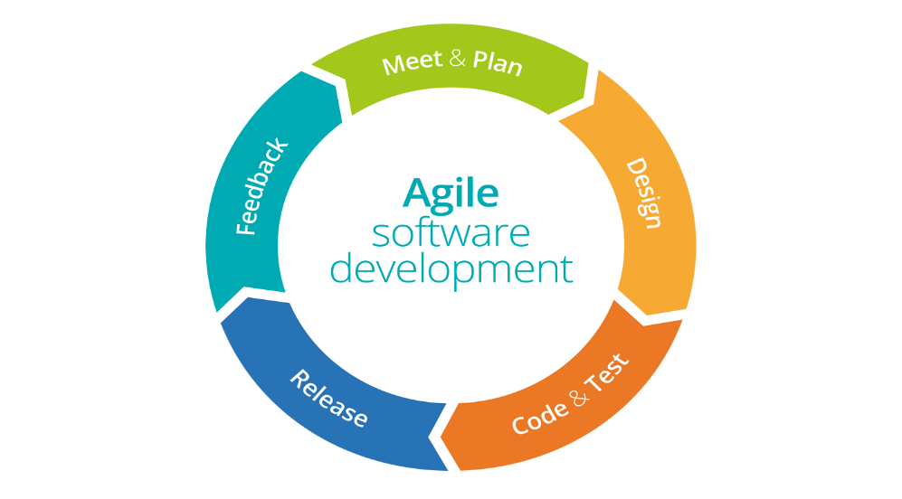

figure 1 Agile Development Cycle 1

**2.3 System architecture.**

The system architecture is Two tier Architecture, the Client side can access the system and get notification from the Server side and the Server side can send the result to the users at the Server side.

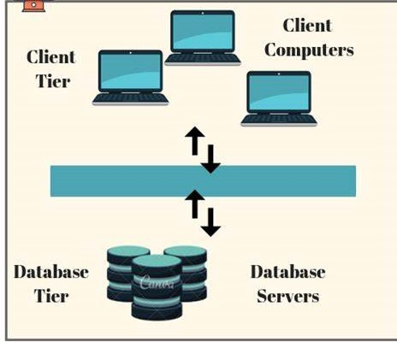

### **2.4 Software development tools**

The technology/tools used include the following:

* **Language**

-JAVA, JavaScript and HTML,SCC,BOOTSTRAP

* **Tools**

- EdrawMax (drawing ERD, Use case diagram and Class diagram)

* **Operating system**

- Window 10

* **Database and Webserver**

- MySQL and Xamp

* **Text editor**

-Intellij IDEA

* **Web browser**

-e browser,firefox and chrome

* **Hardware**
* RAM (8.00 GB)
* Processor (Intelli® Pentium® CPU 2.10 GHz)
* SSD 128GB

**CHAPTER THREE**

**Requirements Analysis and Modelling**

**3.1 Requirement determination**

Requirement determination involves studying the existing system and gathering information’s to find out the exactly requirements, how it works and where improvement should be made.

**3.1.1 Information gathering technique**

While gathering requirement I have used different techniques for collecting the needed requirements. These techniques are as follows:

• Interviews: interview was carried out through means of questions and answers with the client to determine what requirement is needed for the system to be developed.

• Observation: also, an observation was done in order to determine the requirements by looking the processes that happen in the current system.

**3.1.2 Functional requirements**

* The system should allow requesters and sponsors to be register their selves.
* System should allow admin to view all requesters, sponsors registered.
* System should allow admin to view all requests of requesters.
* System should allow admin to send requests recieved to the sponsors
* System should allow sponsors to receive requests from admin
* System should be able to block the requesters who have not enough requirements such as letter from sheha
* System should be able to view user’s profile
* System should allow sponsors requesters if they need to give helps
* System should allow admin, sponsors to download requests sent by the requesters

**3.2.2 Non-functional requirements**

* **Simplicity** – the provided functionalities of the system must be simple and straightforward for the users of the system. The system should be designed in a way that it can be easily understood by users.
* **Interface Design** – the interface design and must have a layout or a format which is easy for users to understand.
* **Usability** – The website must be usable as it is expected to be used by individuals of varying skill levels and technical competences.
* **Easy and properly maintained** - the system should be maintained properly so that it should be able resolve any data conflicts and sustain at any condition.
* **Security**- the system must be secured at any aspects:

## **3.2 USE CASE DIAGRAM**

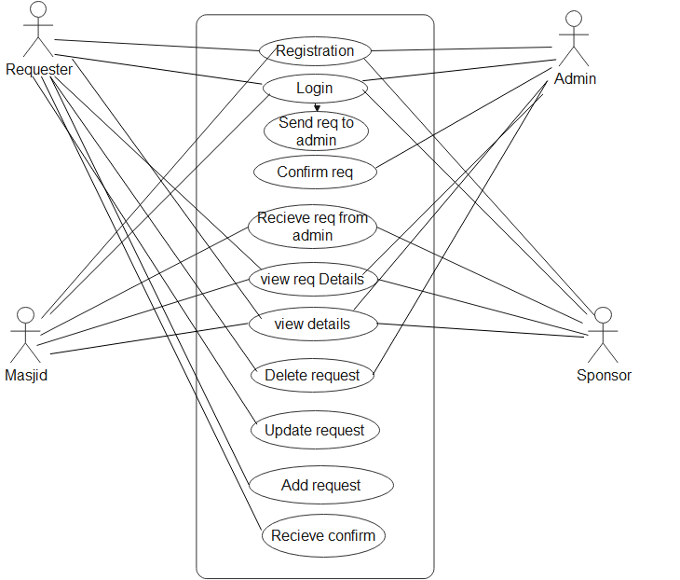

ENTITY RELATIONSHIP DIAGRAM

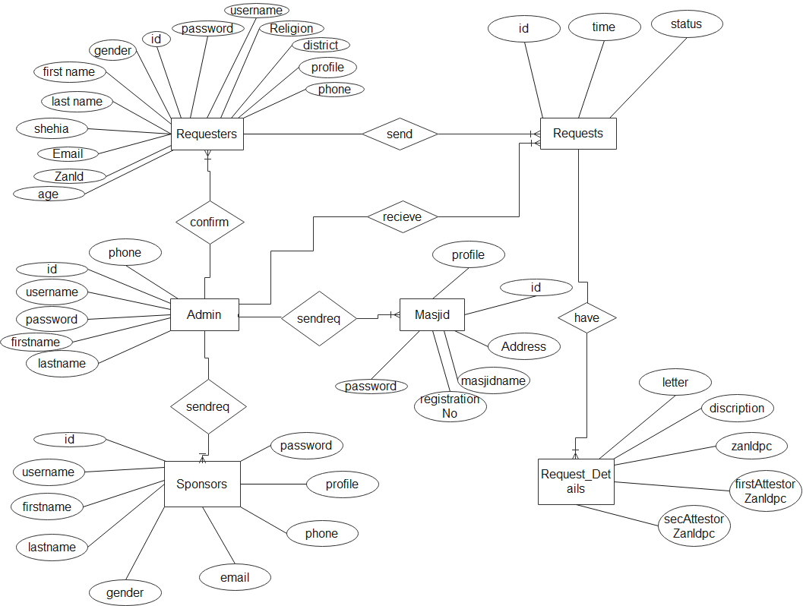

Class Diagram

